LAB 2

NAME = RACHAPPA

SRN = PES1UG19CS359

ROLLNO ==1

1.Implementation of ARM7TDMI code for GCD

.data

num1: .word 6

num2: .word 32

result: .word 0

.text

LDR R1, =num1

LDR R2, =num2

LDR R1, [R1]

LDR R2, [R2]

loop:

CMP R1, R2;

SUBGT R1, R1, R2;

SUBLT R2, R2, R1;

BNE loop

BEQ EX

EX: SWI 0x011

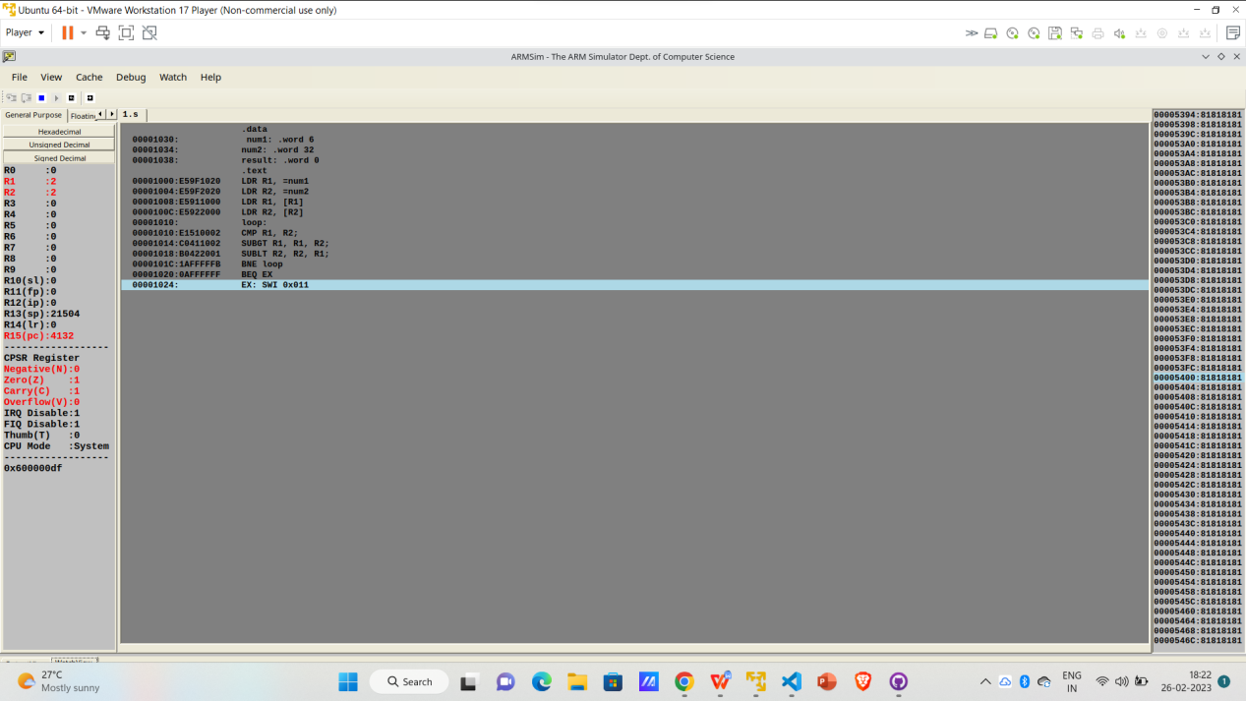

2..Implementation of ARM7TDMI code for factorial.

.data

A: .word 6

.text

LDR R0,=A

LDR R1,[R0]

LDR R3,[R0]

MOV R4,R1

LOOP:

SUB R3,R3,#1

MUL R4,R3,R4

CMP R3,#1

BNE LOOP

SWI 0X011

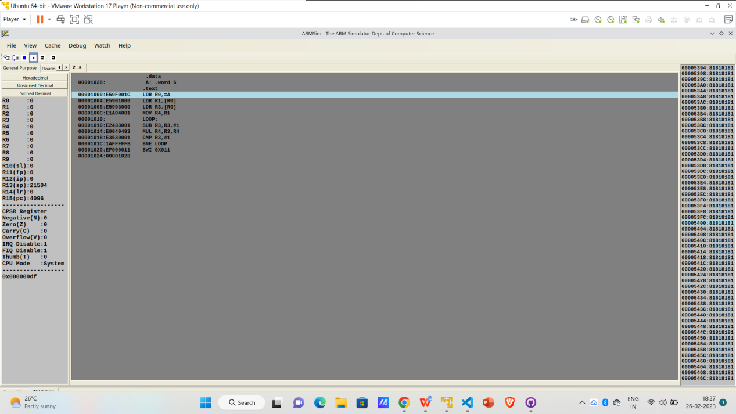

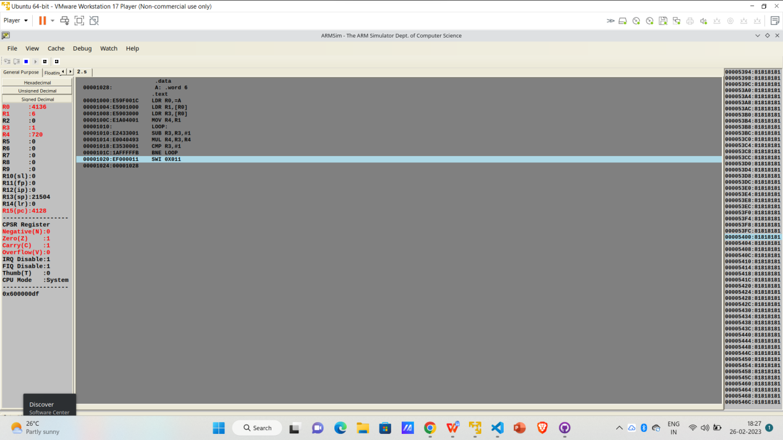

1. Implementation of ARM7TDMI code to generate Fibonacci series,

.data:

A: .word 0, 0, 0, 0, 0, 0

.text:

fibonacci:

MOV r0, #0

MOV r6, #1

MOV r2, #0

MOV r3, #0

MOV r4, #6

LDR r5 ,= A;

loop:

CMP r4, r3

BEQ end

MOV r2, r6

ADD r6, r6, r0

MOV r0, r2

STMIA r5!, {r6}

ADD r3, r3, #1

B loop

end:

MOV r0, r6

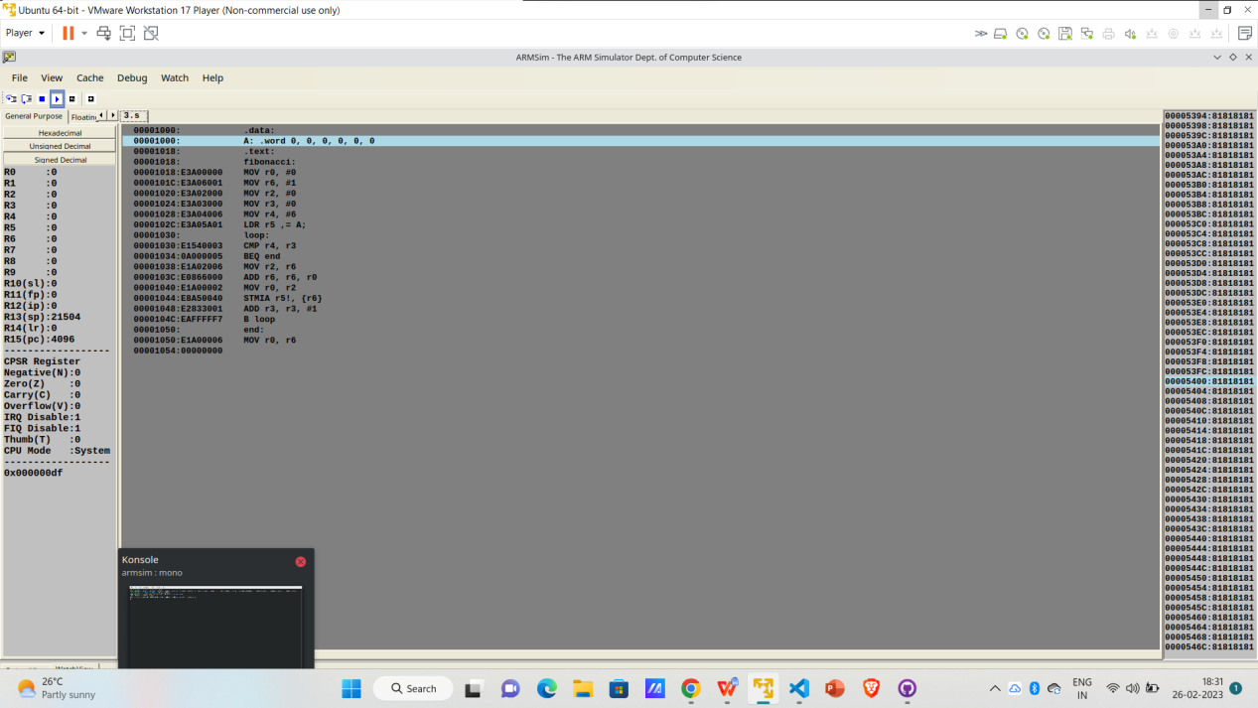

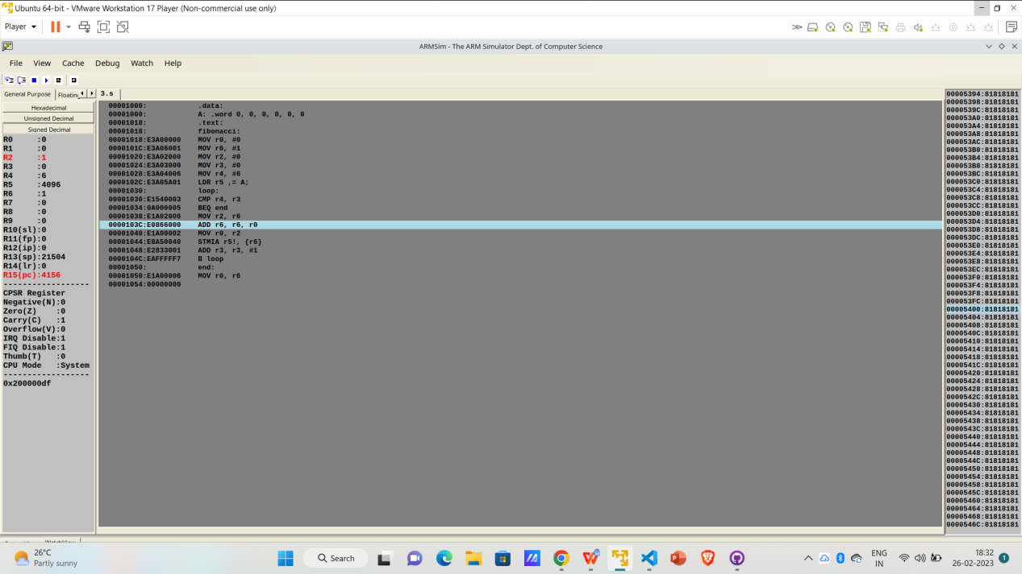

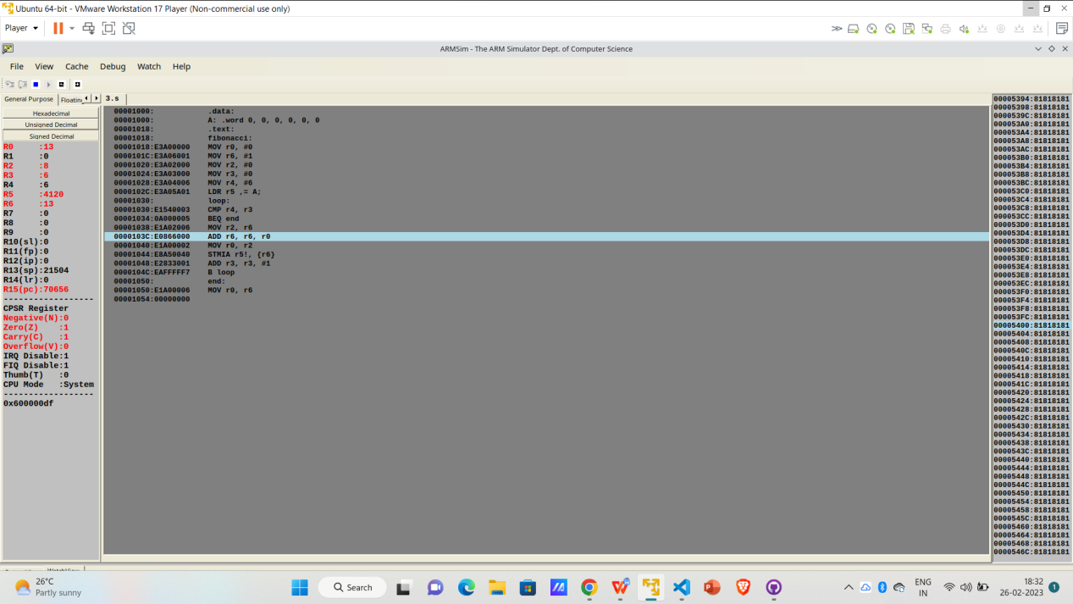

Largest

.TEXT

LDR R1, =A

LDR R2, =B

MOV R3,#5

LDR R5,[R1];R5 IS MAXIMUM VALUE

LOOP:

ADD R1,R1,#4

SUBS R3,R3,#1

CMP R3 ,#0

BEQ END;

LDR R6,[R1]

CMP R6,R5

BGT SWAP

B LOOP

SWAP:

MOV R5,R6

B LOOP

END:

SWI 0X011

.DATA

A: .WORD 1, 2, 10, 4, 5

B: .WORD 0

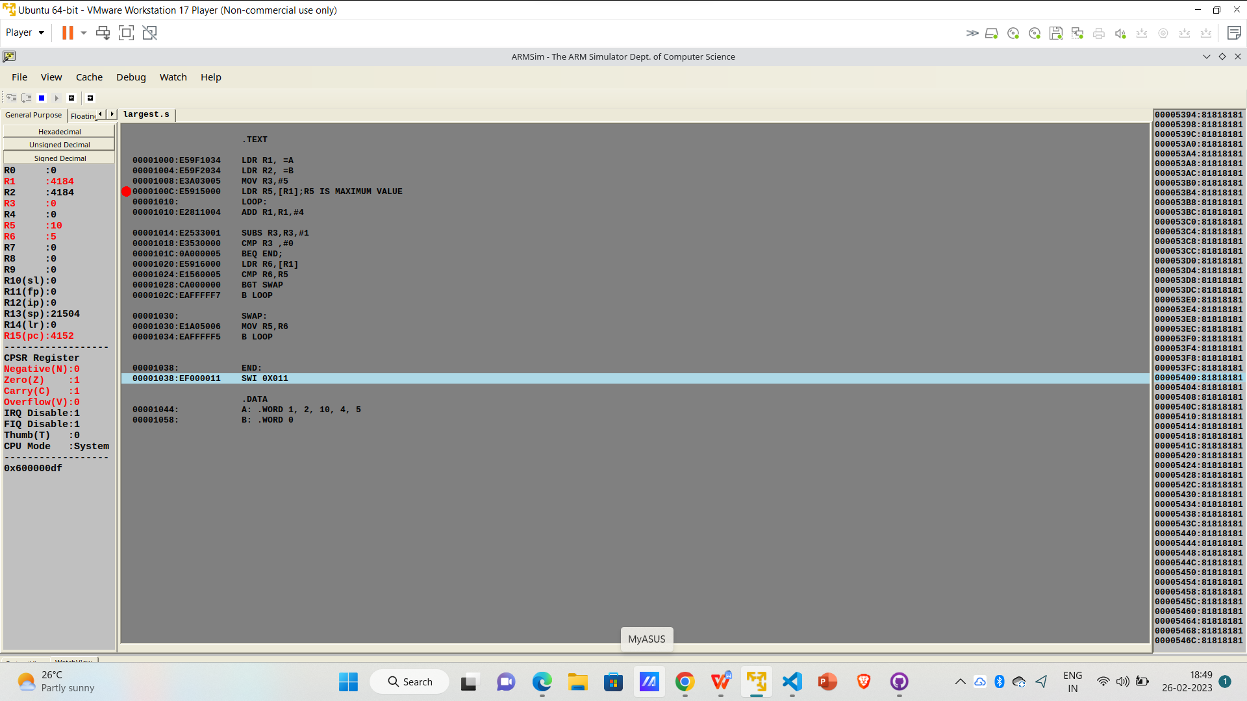

Smallest

.TEXT

LDR R1, =A

LDR R2, =B

MOV R3,#5

LDR R5,[R1];R5 IS MAXIMUM VALUE

LOOP:

ADD R1,R1,#4

SUBS R3,R3,#1

CMP R3 ,#0

BEQ END;

LDR R6,[R1]

CMP R6,R5

BLT SWAP

B LOOP

SWAP:

MOV R5,R6

B LOOP

END:

SWI 0X011

.DATA

A: .WORD 1, 2, 10, 4, 5

B: .WORD 0

